Busch Gardens Homework Packet instructions

Homework will be graded. You either get a Complete (100%) or you get (REDO). REDO paper can be turned in the following day for full credit.

ALL homework is to be done in pencil AND you must write the formula and the steps to get credit. Just putting the answer down will result in a REDO.

Put units in every appropriate step or you will REDO the problems.

Formulas

WR= Resultant Weight (lbs.)  W = Weight (lbs.)  G = G-force | v = velocity (m/s)  d = distance (m)  t = time (s) | vp = predicted velocity (m/s)  h = height (m)
G = G-force  v = velocity (m/s)  r = radius (m) | f = frequency  t = time (s) | F = ma  F = Force (N)  m = mass (kg)  a = acceleration (m/s2)
= acceleration (m/s2)  = final velocity (m/s)  = initial velocity (m/s)  t = time | = momentum (kg•m/s)  m = mass (kg)  v = velocity (m/s) | W=Fd  W = work (J)  F = force (N)  d = distance (m)
To change a velocity from m/s to mi/h: Multiply m/s velocity by 2.24

In questions 1-6, find the missing value:

1) WR = ? 2) WR = ? 3) WR = 280lb
W = 170lb W = 330lb W = 80lb
G = 2 G = 5.2 G = ?

4) WR = 775lb 5) WR = 160lb 6) WR = 663lb
W = ? W = ? W = 85lb
G = 6.2 G = 0.7 G = ?

7) Montu riders experience a maximum G-force of 4.1. Find the resultant weight of a 300 pound person.

8) When the space shuttle takes off, the astronauts experience a G-force of 3.5. Riders of the Kumba experience a maximum G-force of 3.85. Find the difference of the resultant weights of a 220 pound person.

9) A student weighing 90 pounds rides a roller coaster. While on the ride, she feels like she weighs 396 pounds. What G-force did she experience?

10) A coaster has a maximum G-force of 6.2. A student feels like he weighs 899 pounds on the ride. Find the student’s weight.

11) A coaster travels 180 meters in 8 seconds. Find the speed in A) meters per second and B) miles per hour.

12) A truck leaves Bradenton to make a delivery in Tallahassee. The distance between Bradenton and Tallahassee is 335 miles. If the driver left Bradenton at 8:45 am and arrived in Tallahassee at 2:45 pm, find the average velocity of the truck.

13) A coaster has a near vertical drop of 42 meters. Predict its velocity at the bottom of the drop.

14) The time it takes for the coaster in problem 13 to drop 42 meters is 1.9 seconds. Find the coaster’s actual velocity.

15) What is the difference between the answers in problems 13) and 14).

16) Why are the velocities different in problems 13) and 14).

17) Janet ran 800 meters at 3.6 meters per second. Kara ran 350 meters at 1.75 meters per second. If both girls started their runs at the same time, which girl would finish first? Explain your answer.

18) Who would have a higher resultant weight? A) An 800 lb sumo wrestler experiencing a G-force of 0.5 or an 81 pound student experiencing a G-force of 4.2? Explain your answer.

19) A group uses a stopwatch to find the time for a coaster to travel between two points 375 meters apart. They recorded three times: 11.8 seconds, 12.3 seconds, and 12.5 seconds. Find the mean time of the three recorded times.

20) Find the average velocity in problem 19.

21) Find the G-force of a roller coaster that has a velocity of 15 meters per second as it rounds a curve with a radius of 25 meters. (Round your answer to the nearest tenth.)

22) What is the resultant weight of a 115 pound person during the curve in problem 21?

23) A coaster is entering a curve with a radius of 10 meters. It has traveled the last 71 meters in 4.5 seconds. Find the average velocity of the coaster.

24) Find the G-force of the coaster going through the curve in problem 23.

25) Find the resultant weight of a 200 pound teacher using the G-force from question 24.

26) A ride has a maximum G-force of 4.7 and has a radius of 40 meters. Find the velocity when the G-force is at its maximum on the ride.

PRACTICE RIDE #1

 | Trial #1 | Trial # 2 | Trial #3 | Mean Time
Time for the coaster to go around the vertical loop | 7.3 seconds | 6.6 seconds | 7.1 seconds

- Find the mean time for the vertical loop of the coaster.

- Find the velocity of the coaster around the loop using the mean time and knowing the distance is 147 meters.

- How fast is the coaster traveling in miles per hour?

- Find the G-force using the velocity from question 2 and given the radius of the vertical loop is 15.5 meters.

- Find the resultant weight of a 110-pound passenger during the bottom of the loop using the G-force in question 4.

- The height of the tallest hill on the ride measures 28 meters tall. Find the predicted velocity of the car at the bottom of the hill.

- If the actual speed at the bottom of the tallest hill is 24.8 m/s. Why is the velocity different than the one found in question 6

Use the graphs below to answer questions 8 – 12
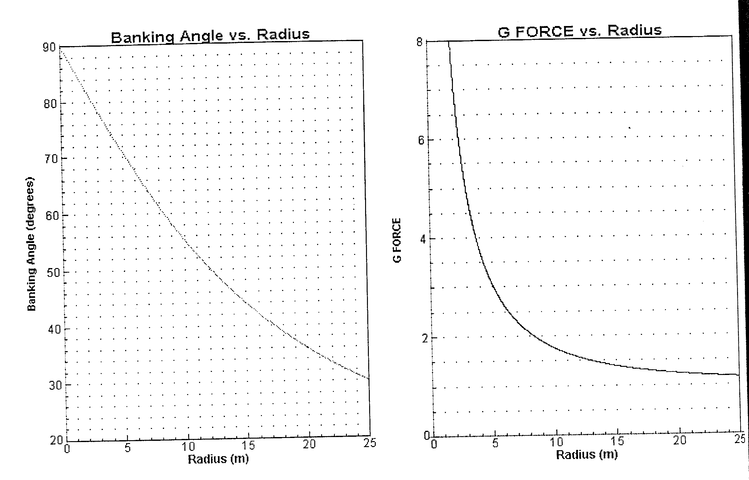

- The radius of the Carrousel is 10.1 meters. According to the graphs, what should the banking angle be?

- What is the G-force associated with a radius of 10.1 meters?

- If the radius is doubled to 20.2 meters, what happens to the banking angle and the G-force?

- If the radius is cut is half to 5 meters, what happens to the banking angle and the G-force.

- What banking angle corresponds to a G-force of 5?

13. Using the time in question #1, the velocity found in question #2 (as Vf), and given , find the acceleration of the coaster during the vertical loop.

14. Using the acceleration in problem #14 and knowing the mass of a loaded cart is 720 kg, find the force (in Newtons) of the loaded cart.

15. Using the velocity from question #2 and the mass of the loaded cart in question #14, find the momentum of the loaded cart.

16. Using the force in question #14 and knowing the distance is 147 meters; find the work of the loaded cart.

17. The maximum G-force of the ride is 3.9. The radius of the track at that time is 32 meters. Find the velocity (rounded to the nearest whole number.)

PRACTICE RIDE #2

1. Time for the coaster to pass the top of the loop (#9) was 1.04 seconds.

2. The time for the coaster to pass between points A and C was .94 seconds.

3. At the bottom of the first drop, the speed is 27 m/s. Just before the flat spin at the end of the ride the speed is 18 m/s. The G-force at both places is 3.4. How can the G-force be so strong at the end of the ride when the speed is much slower?

4. Using your answer for #1, compute the velocity at the top of the second loop (#9). The coaster length is 11.6 meters.

5. Using the velocity in question 4 and given the radius of the second loop (#9) is 5.5 m; calculate the G-force experienced on second loop (#9).

6. Using the G-force in question 5, find the resultant weight of a 250 pound passenger on the second loop.

7. Find the velocity of the coaster at point B, just after the Immelman. Use the time it took the coaster to go between posts A and C (question #2) and the fact that the distance between posts A and C is 22 meters.

8. Using the velocity in question 7 and given the radius between A and C is 30 m; calculate the G-force experienced after the Immelman.

9. Using the G-force in question 8, find the resultant weight of a 100-pound passenger after the Immelman.

10. A terrified adult lets loose a 650-hertz scream for 15 seconds. How many sound waves did the adult create?

11. Using the graph G-force vs. Speed, what range of velocities would produce a light feeling at the top of the loop (G-force less than 1 and greater than 0.)

Between _____________m/s and ______________m/s

12. A coaster designer has proposed to redesign the loop with a height of 8 meters. Use both graphs below to predict the velocity and the resulting G-force at the top.

Velocity:___________________ G-force:______________________

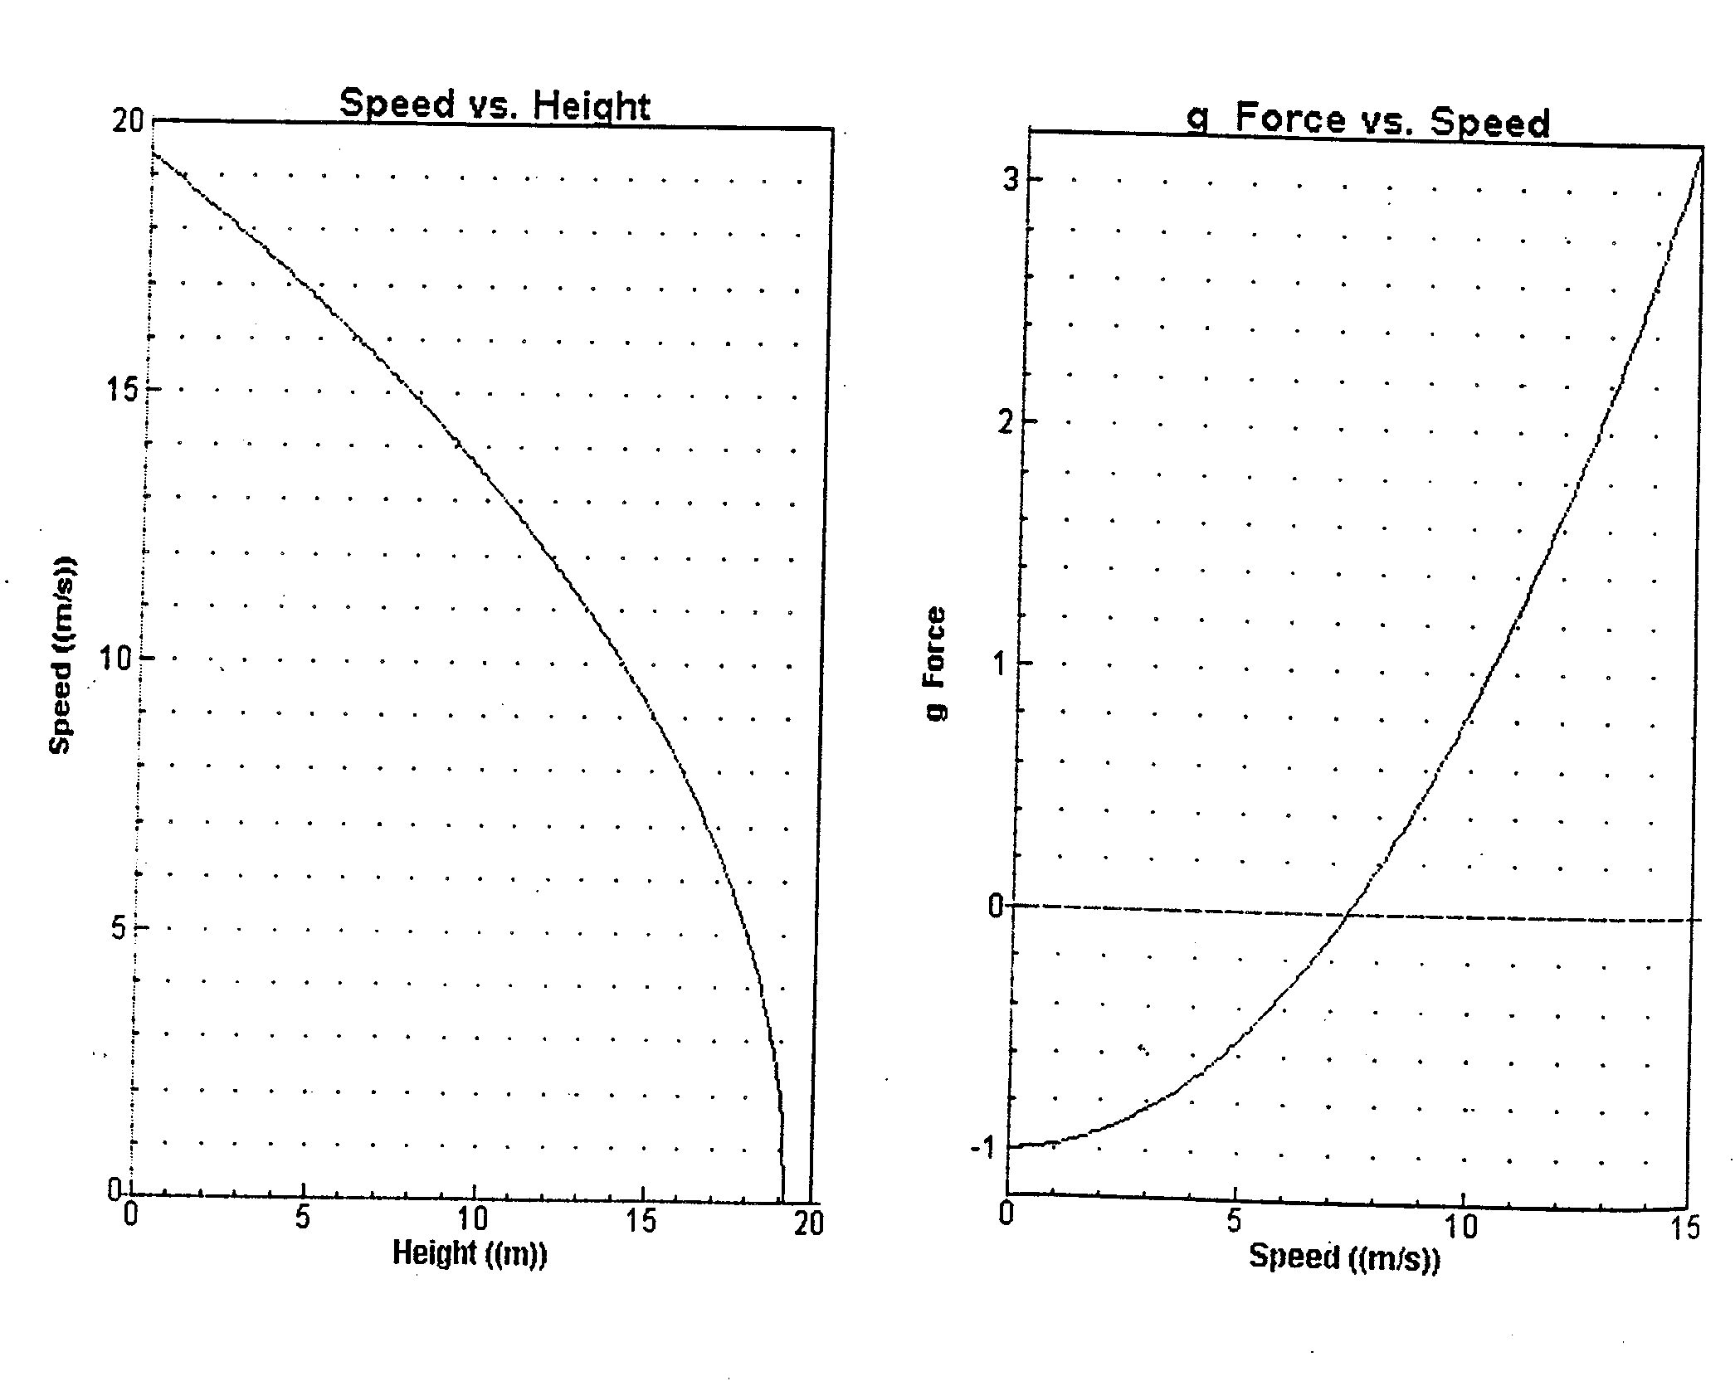

13. Using the time in question #2, the velocity found in question #7 (as ), and given , find the acceleration of the coaster from post A to post C.

14. Using the acceleration in problem #13 and knowing the mass of a loaded cart is 1200 kg, find the force (in Newton) of the loaded cart.

15. Using the velocity from question #7 and the mass of the loaded cart in question #14, find the momentum of the loaded cart.

16. Using the force in question #14 and knowing the distance between post A and post C is 22 meters; find the work of the loaded cart.

